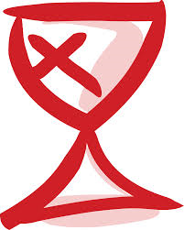
Florida Disciples Regional Church
Outdoor Ministry Program
Summer Camp
2017 Dates

All camps will be held at The Retreat at Silver Springs,
the conference center of the Florida Disciples Regional Church.

In Chronological Order:

Young Adult Canoe Camp H.S. Grads – Age 25 June 2 - 7
Elementary Equestrian Camp Grades 3 - 5 June 11 – 16
CYF Conference Grades 9 - 12 June 11 – 17
Midway Camp Grades 6 - 8 June 18 – 23
High School Canoe Camp Grades 9 - 12 June 25 – July 1
Junior Camp Grades 3 - 5 June 25 – 30
Young Adult Camp H.S. Grad – Age 25 July 14 - 16
Spiritual Arts Camp Grades 8 - 12 July 16 – 22

Middle School Canoe Grades 6 - 8 July 23 – 28
Middle School Equestrian Grades 6 - 8 July 23 – 28
UNO Camp Grades K - 2 (with a loving adult) July 28 – 30
Family Camp for the WHOLE Family October 6 - 8

